C3-S2-PRACTICE

# Instructions: : you can use your favorite SQL editor

**Exercise 1:** [**Databases on W3School**](https://www.w3schools.com/sql/trysql.asp?filename=trysql_select_all) **(on the right side)**

1. **Selecting**

Write statements to extract data from all tables from w3shool order at least one column by ASC and other one by DESC.

* 1. **Customers : select * from customers order by customername DESC;**

**select * from customers order by country ASC;**

**b. Categories : SELECT * FROM Categories order by categoryname DESC;**

**SELECT * FROM Categories order by description ASC;**

**c. Employees : SELECT * FROM Employees order by lastname ASC;**

**SELECT * FROM Employees order by firstname DESC;**

**d. OrderDetails : SELECT * FROM OrderDetails order by orderid DESC;**

**SELECT * FROM OrderDetails order by productid ASC;**

**e. Orders : SELECT * FROM Orders order by employeeid ASC;**

**SELECT * FROM Orders order by shipperid DESC;**

**f. Products : SELECT * FROM Products order by productname ASC;**

**SELECT * FROM Products order by price DESC;**

**g. Shippers : SELECT * FROM Shippers order by shippername DESC;**

**SELECT * FROM Shippers order by shipperid ASC;**

**h. Suppliers : SELECT * FROM Suppliers order by city ASC;**

**SELECT * FROM Suppliers order by contactname DESC;**

1. **Where clause** 
   1. Write a statement to extract all data from products where the price equal to 19.5.

SELECT * FROM Products WHERE Price = 19.5;

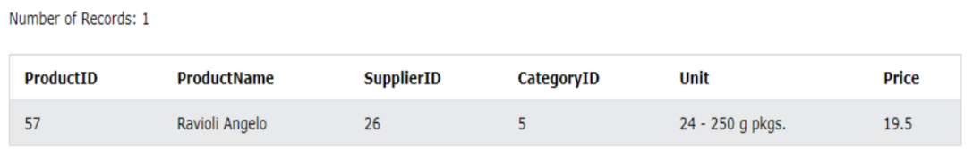

* 1. Write a statement to extract all data from ordereDetail where the Quantity greater than 10.

SELECT * FROM OrderDetails WHERE Quantity > 10;

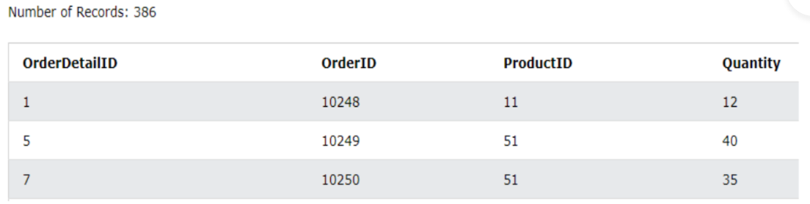

* 1. Write a statement to extract all data from shippers where the shipperid less than 3.

SELECT * FROM Shippers WHERE ShipperID < 3;

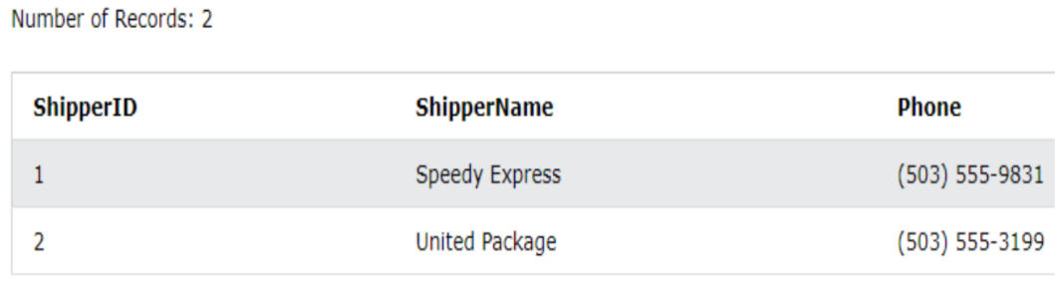

* 1. Write a statement to extract all data from products where the price is Greater than or equal to 40.

SELECT * FROM Products WHERE Price >= 40; 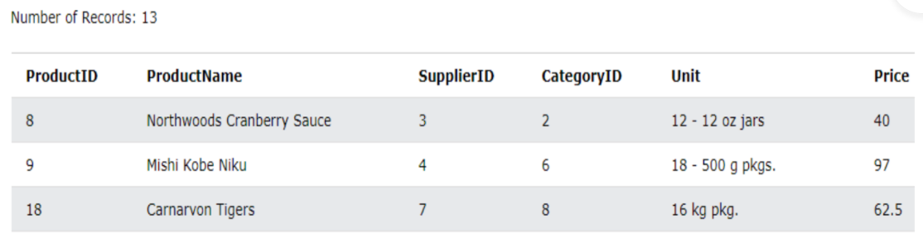

* 1. Write a statement to extract all data from products where SupplierID is Less than or equal to 9.

SELECT * FROM Products WHERE SupplierID <= 9;

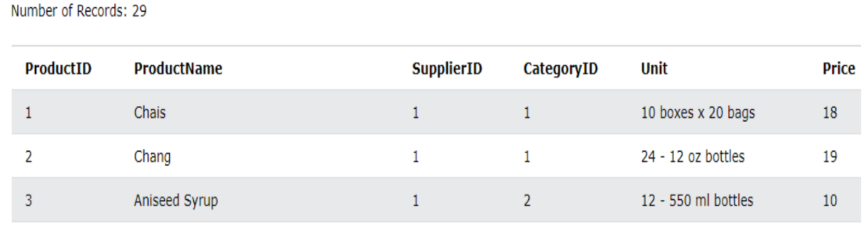

* 1. Write a statement to extract all data from customers except “Canana”.

SELECT * FROM Customers WHERE not Country = "Canada";

Or

select * from customers where country!='Canada';

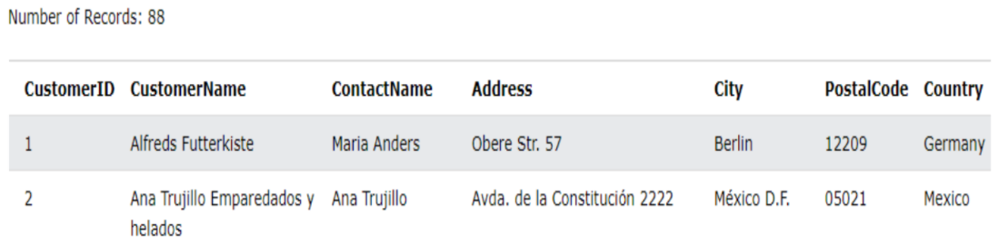

* 1. Write a statement to extract all data from products where the price is between 10 to 30.

SELECT * FROM Products WHERE Price >= 10 and Price <= 30;

OR

SELECT * FROM Products WHERE Price between 10 and 30;

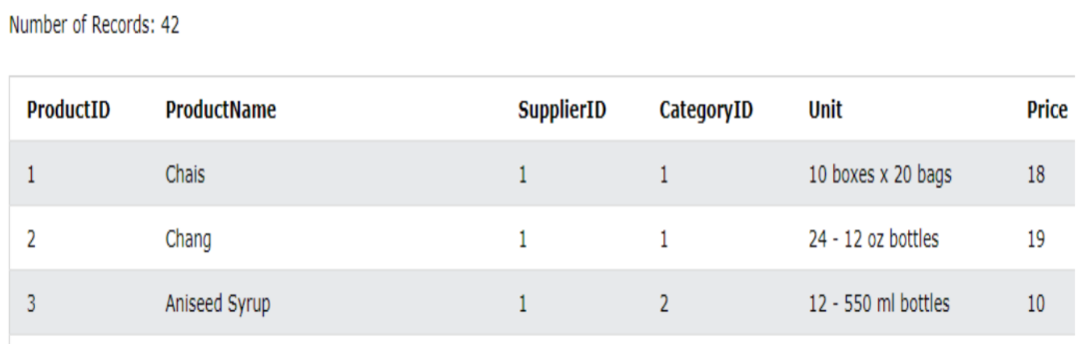

* 1. Write a statement to extract all data from customers where the customername start with letter O.

SELECT * FROM Customers WHERE CustomerName LIKE 'O%';

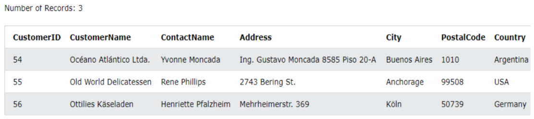

* 1. Write a statement to extract all data from suppliers where the country is in “USA, Italy,France”

SELECT * FROM Suppliers WHERE Country in ("USA", "Italy", "France");

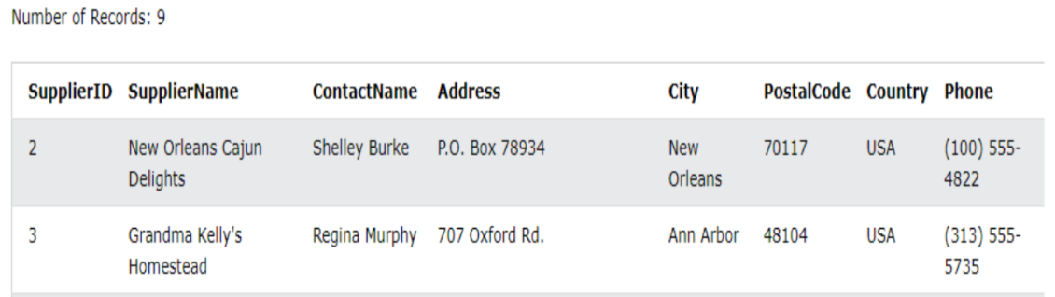

**Exercise 2**

**Nobel Table**

year subject winner country category

1970 Chemistry Luis Federico Leloir France

1971 Chemistry Gerhard Herzberg Germany

1999 Physics Rith Nhel Cambodia scientist

2020 physics Hannes Alfven Sweden scientist

2020 economics Robert solow USA economist

2020 computer science Ronan Ogor France best teacher

Q1 Write a SQL query to know the winner of the 1971 prize for Literature.

Expected result:

winner

Pablo Neruda

**Your query:**

SELECT * FROM nobel WHERE year=19701 AND subject = 'Literature';

Q2 Write a SQL query to show all the details (year, subject, winner, country) of the Chemistry prize winners between the years 1965 to 1975 inclusive

Expected result:

year subject winner country

1970 Chemistry Luis Federico Leloir France

1971 Chemistry Gerhard Herzberg Germany

**Your query:**

SELECT year, subject,winner, country from nobel WHERE year between 1965 AND 1675 and subject = ' Chemistry ';

Q3 Write a SQL query to show all details of the Prime Ministerial winners after 1972, among the following winners: Menachem Begin and Yitzhak Rabin

Expected result:

year subject winner country category

1978 Peace Menachem Begin Israel Prime Minister

1994 Peace Yitzhak Rabin Israel Prime Minister

**Your query:**

SELECT * FROM Nobels where category = “Prime Minister” and year > 1972 and winner in

(“Menachem Begin”, “Yitzhak Rabin”);

Q4 Show all the winners of Nobel Prize in the year 1970 except the subject Physiology and Economics

Expected result:

year subject winner country category

1970 Physics Hannes Alfven Sweden Scientist

1970 Physics Louis Neel France Scientist

1970 Chemistry Luis Federico Leloir France Scientist

1970 Literature Aleksandr Solzhenitsyn Russia Linguist

**Your query:**

SELECT * FROM nobel_win WHERE year=1970 AND subject NOT IN('Physiology','Economics');

Q5 Write a query in SQL to find the last name of all categories, without duplicates

Expected result:

category

Scientist

Economist

Chancellor

Linguist

President

Prime Minister

**Your query:**

SELECT distinct categories from nobels;

Q6 Display the name of winners of category Linguist - Results shall be **sorted** according to name of the winners

Expected result:

Winner

Aleksandr Solzhenitsyn

Joseph Brodsky

Kenzaburo Oe

Pablo Neruda

**Your query:**

SELECT winner FROM nobel WHERE categories = ‘ Linguist’ order by winner ASC ;